
For Immediate Release Contact: Ginger Campbell
SNAP Productions
ginger@snap-productions.com
323.933.4155

AN ITALIAN VACATION THAT SHOWS THE WAY…TO WEIGHT LOSS
Travel Guru Creates an Italian Experience for Those Who Want to Lose Weight Effortlessly
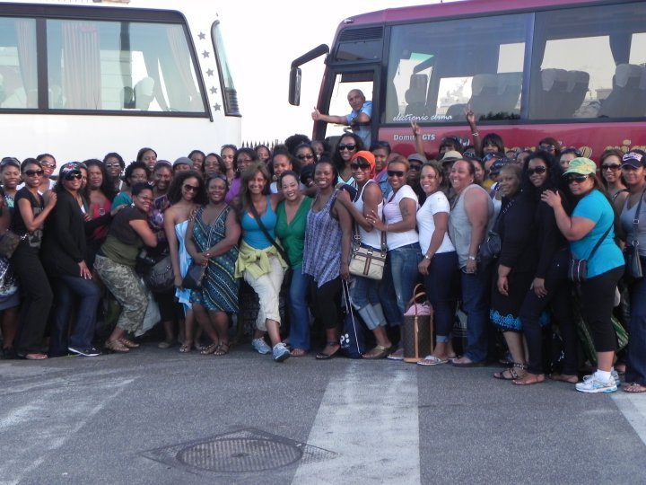
Los Angeles – (November xx, 2011) – African American women have a higher propensity towards weight-related illnesses such as stroke, high blood pressure, and diabetes than non-Black women in all age categories. With 2012 just around the corner, many have earmarked January 1st as the start of their new gym and diet routines. However, travel guru Fleacé Weaver, founder of BlackGirlTravel.com, a travel club for fun-loving Black women, has a more unique idea. Her trips are about more than just travel—they focus on empowerment through exploration. For the adventuresome, she has created an exhilarating new Italian getaway with a focus on weight loss and healthy lifestyle changes. From September 15th – 25th, 2012, ten curvaceous women, who have a few pounds they want to shed, have the opportunity to participate in the newly launched Bella BootCamp in Rome, Italy.
These are not your grandmother’s tours! “I was inspired to create Bella BootCamp by the many women who participate in our widely popular Bella Italia tours that are surprised by the average weight loss of 5-10 pounds during the course of their 10-day vacation,” says Weaver. “I thought, what would happen if we motivated them to push a little further and combine the whirlwind paced Bella Italia with a structured weight loss program? It’s a natural combination. There are women out there who love to travel and want to go on our tours, but oftentimes shy away from such out of fear or concern that the lack exercise at home will make it difficult to keep up with the group. With the help of fitness experts, I designed a special tour just for them. It includes many highlights of the Bella Italia itinerary, but also incorporates time to teach participants about the benefits living a Mediterranean lifestyle, such as active leisure activities, learning healthy Italian cooking, and working with a fitness trainer. There are a lot of healthy attributes about the Italians lifestyle where obesity is rare, despite an abundance of pasta and other delectable dishes. In Italy the word dieting is a foreign concept! That idea was the genesis of Bella BootCamp.” The tour where you can also bring home a better body as a souvenir!
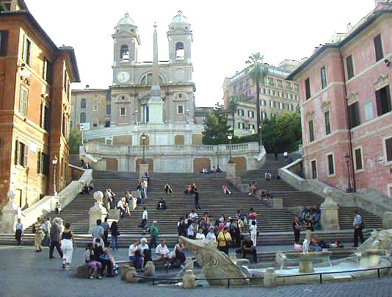
When in Rome …! Weaver wants her “Bellas” (tour participants) to get the pulse of the city, so she eschews bus tours for common local lifestyle choices like walking and bicycling. There’s no Stairmasters here. The girls will get a great workout by climbing the Spanish steps—the widest set of steps in Europe. The 138 steps are on a steep slope between the Piazza di Spagna at the base and Piazza Trinità dei Monti at the top—which allows the spectators a magnificent view of Rome at their summit. Imagine power walking down ancient streets walked by Bernini and Michelangelo or cycling through the Villa Borghese gardens, the former private estate of Princess Borghese. Visualize a sexy male Italian personal trainer teaching “the moves” on Ponte Sant'Angelo (the Bridge of Angles) stretching over the Tiber river to Castel Sant'Angelo. Picture losing weight by just living "la vita è bella” (the beautiful life) or as the Italians say “Sprezzatura” (the art of making difficult tasks seem effortless)!
Weaver also seeks to maximize the experience for the participants, so she has secured condos in which the girls reside during their vacation. To kick-start the weight loss goal, the girls will be broken into small support teams to increase accountability within the challenging games being presented. Friendly competition will not only encourage camaraderie among the participants, but will also maintain a support system for those tempted to fall off track. They will be encouraged to cook healthy meals together and Weaver will bring in a cooking instructor to teach them healthier food preparation.
Though fun is one of the focuses, the main purpose of the tour is educational vacationing while exploring the picturesque Italian landscape. During the day, the group will it see some of the amazing highlights of Rome such as Vatican City, the Pantheon, Piazza de Popalo, the Coliseum, and Trevi Fountain, among others. The tour includes day trips to Florence, Naples and the Island of Capri with an optional visit to Venice. But of course, what would a BlackGirlTravel.com tour be without exciting nightlife? Therefore, Weaver ensures that all of her girls get to experience evenings Bella Italia style where one can dance off pounds until 5:00 a.m. most nights of the week.
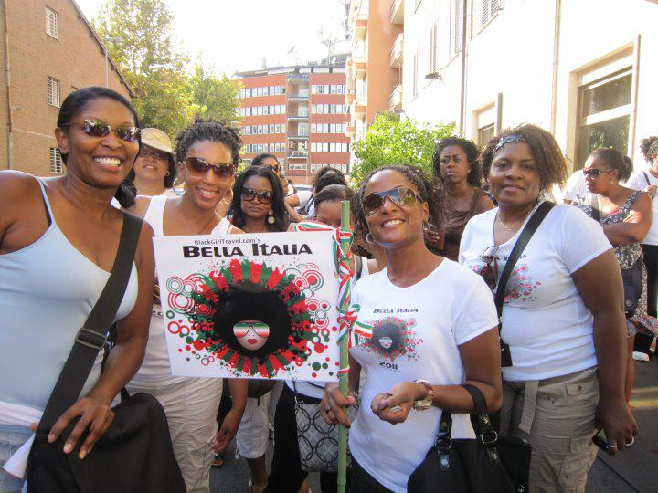
“For me, I think this is a great way for women to get away, free their mind, and explore a new culture while enhancing their lives. By adapting to healthier ways to enjoy your life, the dropping of unwanted pounds becomes a simple byproduct of the mind and lifestyle shift. Weight loss becomes fun and easy,” says Weaver exuberantly. “My company BlackGirlTravel.com and the Bella Italia tours have been so popular because they allow women of color from all over the U.S. to come together in a foreign country and to make life-long friendships, share memories and maybe learn something about themselves along the way. Many leave with a life changing attitude. The tours are about empowering Black women with new and different options.
For more information on the Bella BootCamp, visit www.BlackGirlTravel.com/bellabookcamp or email BootCamp@BlackGirlTravel.com.

About Black Girl Travel:
Founded by Fleacé Weaver, BlackGirlTravel.com is a travel club for fun loving travelers. It creates extraordinary travel for extraordinary women. The goal is simple... to expose Black women to the beauty of the world and the world to the beauty of Black women. We create unique customized tours and meeting programs for groups and individuals. The tours are designed for "young at heart" well-heeled urbanites interested in exploring new lands while indulging in local culture, international cuisine, retail therapy, and exciting nightlife. There simply is no such thing as a 'regular tour' at BlackGirlTravel.com. We don't take existing tours by other companies and tweak them! Ms Weaver began the planning of each tour from scratch with pen, paper, maps, and a vision to maximize the time spent in each country. With her creative flair and "can do" attitude, she has earned a reputation for designing unique travel experiences with the special needs and desires of progressive Black women in mind. So, whether you are the seasoned traveler looking for something different or a newbie seeking the security of a group, we have a tour for you! These are not your grandmother's tours!

# # #

